Bus station
Local transportation
Walk distance from the Bus Station to the Library and Information Centre- Seminar Room, Building K21, following the red dots on the map.
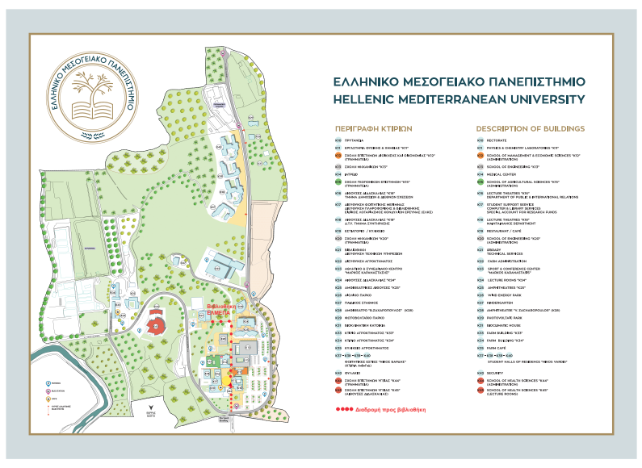

Bus stop : ELMEPA –ΤΕΙ
Line 12, every 15-20 minutes from 6:00 a.m. to 0:50 p.m.
Ticket’s cost : 1.20€
Daily ticket’s cost 5.00€

By Air
The airport of Heraklion is the biggest in Crete. Holiday charter flights arrive at Heraklion and Chania from many European airports. There are daily flights from Athens and Thessaloniki to Heraklion and Chania and also a daily flight to Rhodes.
Kazantzakis airport: 0030 2810 228402
Airport Police Station: 0030 2810 246720

By Ferry
Regular ferry services run from from Piraeus (Athens) to ports at Heraklion and Chania. Ferries usually leave in the evening and arrive the following morning. The main ferry firms serving Crete are:
ANEK Lines, Information: https://www.anek.gr/en/
Piraeus 0030 210 4197510, pr-pir@anek.gr
Heraklion, 0030 2810 222481-2, ira-ag@anek.gr
Minoan Lines, Information: https://www.minoan.gr/
Heraklion, 0030 2810 399899, info@minoan.gr
SeaJets, Information: https://www.seajets.com/
Piraeus 0030 210 7107710, reservations.dpt@seajets.gr, info@seajets.gr.
Port Police 108/ 0030 2810 244912

Transportation in the city and around

City Buses (blue) serving the city of Heraklion from early morning until late evening. Starting from the port city services operated in the archaeological site of Knossos. Information: 2810-226065 and 220795. Web: http://astiko-irakleiou.gr/
Intercity Buses (green) connecting Heraklion with all the counties of Crete for easy movement of residents and visitors. KTEL runs regular buses between Rethymno and Chania and there are services to many inland villages. Taxis are common and relatively cheap. Fares are regulated and metered.
Web: http://www.ktelherlas.gr
Information 0030 2810 246534, info@ktelherlas.gr , webinfo@ktelherlas.gr
Taxi services in Heraklion.
www.crete-taxi.gr
0030 6970021970, 0030 6945027933
https://www.herakliontaxi.com/en/index.html,
0030 2814 003084, 0306945774937
https://gettransfer.com/en
www.cretetaxi.net
0030 697 002 1970
crete-heraklion-chania.taxi
0030 694 491 5683

Useful telephones
Police 100
Ambulance 166 / 0030 2810 222222
Coast Guard 108
Forest Fire Center 191
Fire Department 199
Tourist police 171/ 0030 2810 274046
Municipal Police 0030 2810 334181-5
Municipality of Heraklion 0030 2813 409000
Crete Region Tourism Division 0030 2810 246100
Post Office, Daskalogianni square, 0030 2810 234468
Hospitals
Regional Academic Hospital- PAGNH Tel. 0030 2813 402111
Venizeleio General Hospital Tel. 0030 2813 408000

