**Venetian Candia**

**Loggia**

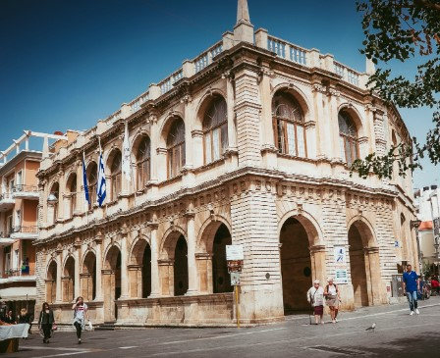

*Loggia the city hall of Heraklion and one of the finest Venetian monuments of Crete* (2023). Daily Crete, <https://www.dailycrete.com/2020/09/loggia-architectural-gem-of-heraklion.html>

**Basilica Di San Marco**

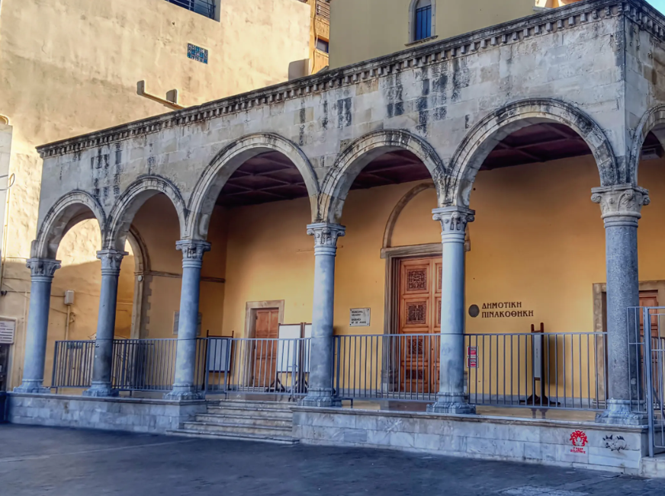

[*Venetian Buildings*](https://aboutheraklion.com/categories/venetian-buildings/)*: Basilica Di San Marco* (2020), <https://aboutheraklion.com/sightseeing-in-heraklion/basilica-di-san-marco/>

**Morosini fountain**

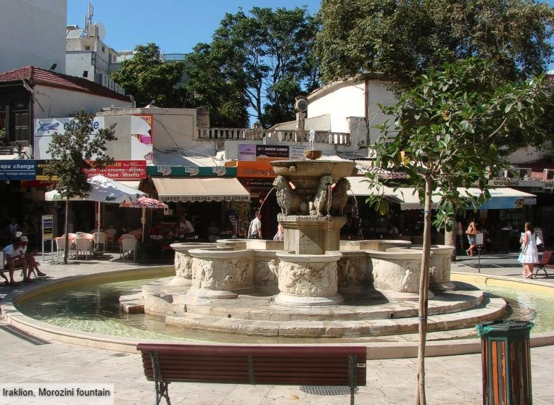

*Morosini fountain.* InterKriti, <https://www.interkriti.org/crete/iraklion/morosini_fountain.html>

**Rocca al Mare  or Koules Castle**

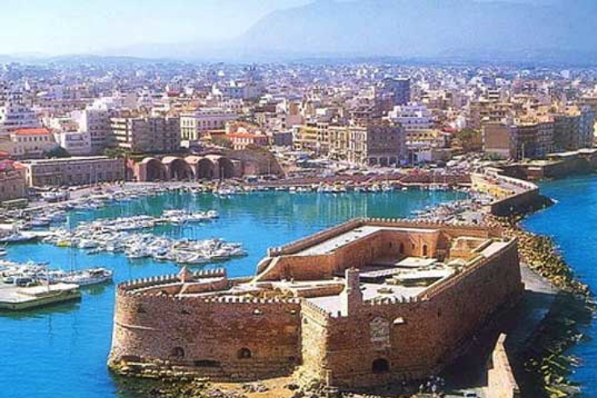

*Koules castle or Rocca al Mare.*Kastrologos,

<https://www.kastra.eu/castleen.php?kastro=koules>

Video “Candia 1640”

<https://www.youtube.com/watch?v=Lg12WMhCPj8>